- (10) Given the grammar below, identify which sentences are in the language (which are valid sentence).
  - baab
  - bbbab
  - bbaaaaaa
  - bbaab
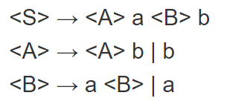
    - baab
<S> => <A>a<B>b
=> ba<B>b
=> baab
Valid
    - bbbab
<S> => <A>a<B>b
=> <A>ba<B>b
=> <A>bba<B>b
=> bbba<B>b
=> bbbaab
Invalid (cannot be one ‘a’)
    - bbaaaaaa
<S> => <A>a<B>b
=> <A>ba<B>b
=> bba<B>b
Invalid (only ‘b’ can terminate this)
    - bbaab
<S> => <A>a<B>b
=> <A>ba<B>b
=> bba<B>b
=> bbaab
Valid

- (10) Identify all of the tokens (categories of lexemes) in the grammar below, and which lexemes they categorize. Put them in a table.
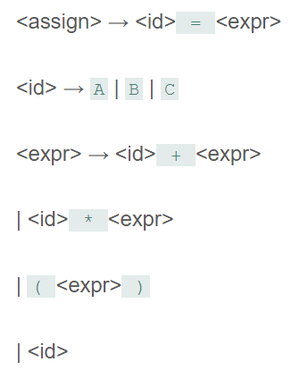
tokens | lexems
Id | A
Id | B
Id | C
add_op | +
multiply_op | *
Parenthesis | (
Parenthesis | )
Assgn_op | =

- (10) Given the grammar from question 2, show a left-most derivation and draw the parse tree for the following statement.
  - B = B + (C + (A * A) )
<assgn> => <id> = <expr>
=> B = <expr>
=> B = <id> + <expr>
=> B = B + <expr>
=> B = B + (<expr>)
=> B = B + (<id> + <expr>)
=> B = B + (C + <expr>)
=> B = B + (C + (<expr>))
=> B = B + (C + (<id> * <expr>))
=> B = B + (C + (A * <expr>))
=> B = B + (C + (A * <id>))
=> B = B + (C + (A * A))
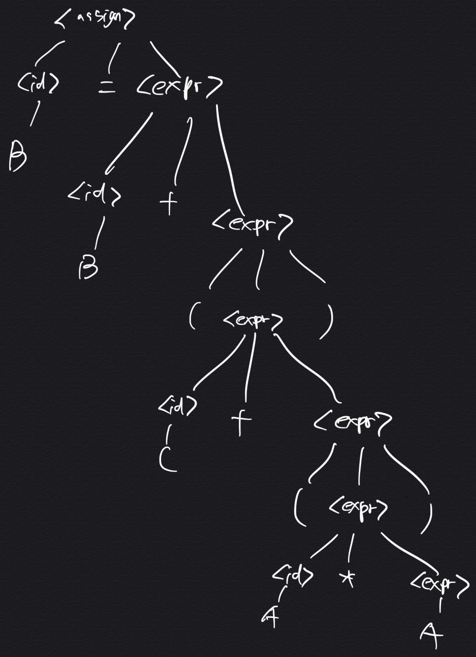
- (10) Remove all of the recursion from the following grammar:
S -> Aa | Bb
A -> Aa | AbC | C
B -> S | bb
C -> c

S-> Aa|Bb
A-> CA’|SbA’
A’-> aA’|bcA’|ε
B-> bb
C-> c
- (10) Use left factoring to resolve the pairwise disjointness problems in the following grammar:
A -> aBc | ac | a
B -> b | aB
A-> aA’
A’-> Bc|C| ε
B-> b|aB
- (20 pts) Create an LR(0) parse table for the following grammar. Show all steps (creating closures, the DFA, the transition table, and finally the parse table):
E -> E + T | E * T | T
T -> ( E ) | id

- Closures
I1 = closure(E’->E)
= [E’->E]
[E->E+T]
[E-> E*T]
[E->T]
[T->(E)]
[T->id]

I2 = closure(move(I1, E))
= [E’->E]
[E->E+T]
[E->E*T]

I3 = closure(move(I1, T))
=[E->T]

I4 = closure(move(I1, 1))
=[T->(E)]
= [E->E+T]
[E->T]
[T->(E)]
[T->id]

I5 = closure(move(I1, id))
= closure([T-> id])
=[T->id]

I6 = closure(move(I2, +))
= [E->E+T]
[T->id]

I7= closure(move(I2, *))
= [E->E*T]
[T->id]

I8= closure(move(I4, E))
=[T->(E)]
[E->E*T]

- DFA
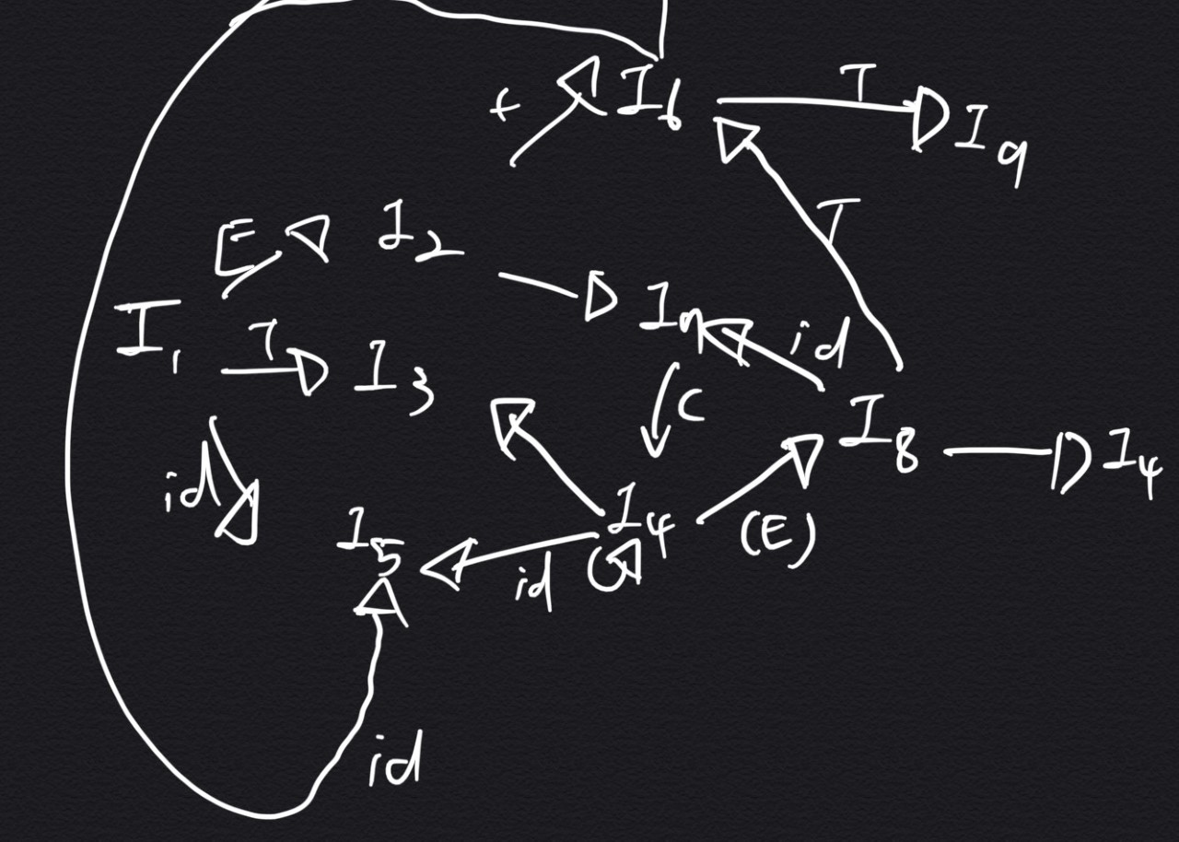
- Parse Table
 | ( | id | + | * | ) | $ | E | T
I1 | S4 | S5 |  |  |  |  | 2 | 3
I2 |  |  | S6 | S7
I3 |  |  | R1 | R1 | R1 | R1
I4 | S4 | S5 |  |  |  |  | 3 | 3
I5 |  |  | R6 | R6 | R6 | R6
I6 | S4 | S5 |  |  |  |  |  | 9
I7 | S4 | S5 |  |  |  |  |  | 10
I8 |  |  | S6 | S7 | S11
I9 |  |  | R2 | R2 | R2 | R2
I10 |  |  | R3 | R3 | R3 | R3
I11 |  |  | R5 | R5 | R5 | R5

- (20 pts) Show a complete bottom-up parse, including the parse stack contents, input string, and action for the string below using the parse table you created in step 6. Think about how I went through this in class.

(id + id) * id
- Grammar: R1-> E-> E+T
R2 -> E-> T
R3 -> T -> T*F
R4 -> T-> F
R5 -> T -> (E)
R6 -> F -> id
Input = (a + b)*c

Stack | Input | Action
0 | (a+b)*C$ | Shift4
0(4 | a+b)*C$ | Shift5
0(4a5) | +b)*C$ | I = -> id(R6)
0(4F3 | +b)*C$ | T->F(R4)
0(4T2 | +b)*C$ | F->T(R2)
0(4E8 | +b)*C$ | Shift6

Stack | Input | Action
0(4E8 + 6 | b)*($ | Shift5
0(4E8 + 6b5 | )*($ | Reduced F->id(R6)
0(4E8 + 6F3 | )*($ | R…T->F(R4)
0(4E8 + 6T9 | )*($ | R…E->E+T(R1)
0(4E8 | )*($ | Shift11
0(4E8) | *($ | Reduced F->(E)(R5)
0F3 | *($ | R…T->F(R4)
0T2 | *($ | Shift7
0T2*9 | ($ | Shift5
0T2*T(5 | $ | R…F->id(R6)
0T2*F10 | $ | R…T->T*F(R3)
0T2 | $ | R…E->T(R2)
0E1 | $ | accept

- (10 pts) Show a rightmost derivation for the string above, and show how the bottom-up parse you completed in step 7 correctly finds all of the handles for the input string above.
Grammar : F5, E-> E+T|E*T|T
T-> (E)id

I0 : E’->E
E-> E + T|E*T|T
T->(E)|id

I1: closure(I0E)
=E’->E
E->E + T|E*T

I2: closure(I0, T)
=E->T

I3: closure(I0, i)
T->(E)
E->E + T|E*T|T
T->(E)|id

I4: closure(I0, id)
=T->id

I5: closure(I, t)
=E->E+T
E->(E) |id

I6: closure(I1, *)
=E->E*T
T->(E)|id

I7: closure(I7, E)
=T-> (E)
E-> E+T | E*T

I8: closure(I5, T)
=E->E+T

I9: closure(I6, T)
=E-> E*T

I10:closure(I7, ()
=T->(E)

I11: closure(I3, T)
= I2

I12: closure(I3, ()
= I3

I13: closure(I5, ()
=I3

I14: closure(I6, ()
=I3

- DFA
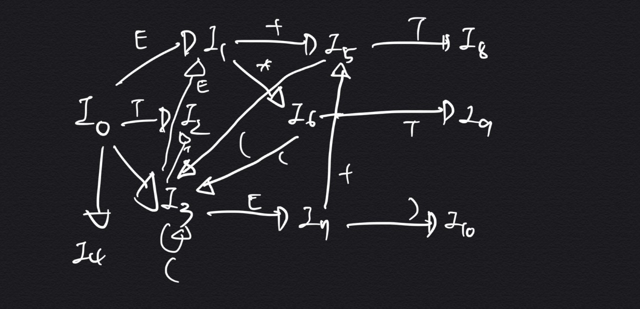
- Parse Table
 | E | T | ( | id | + | * | )
I0 | I1 | I2 | I3 | I4
I1 |  |  |  |  | I5 | I6
I2
I3 | I7 | I2 | I3
I4
I5 |  | I8 | I3
I6 |  | I9 | I3
I7 |  |  |  |  | I5 | I6 | I10
I8

